AXON SALES DATA ANALYSIS

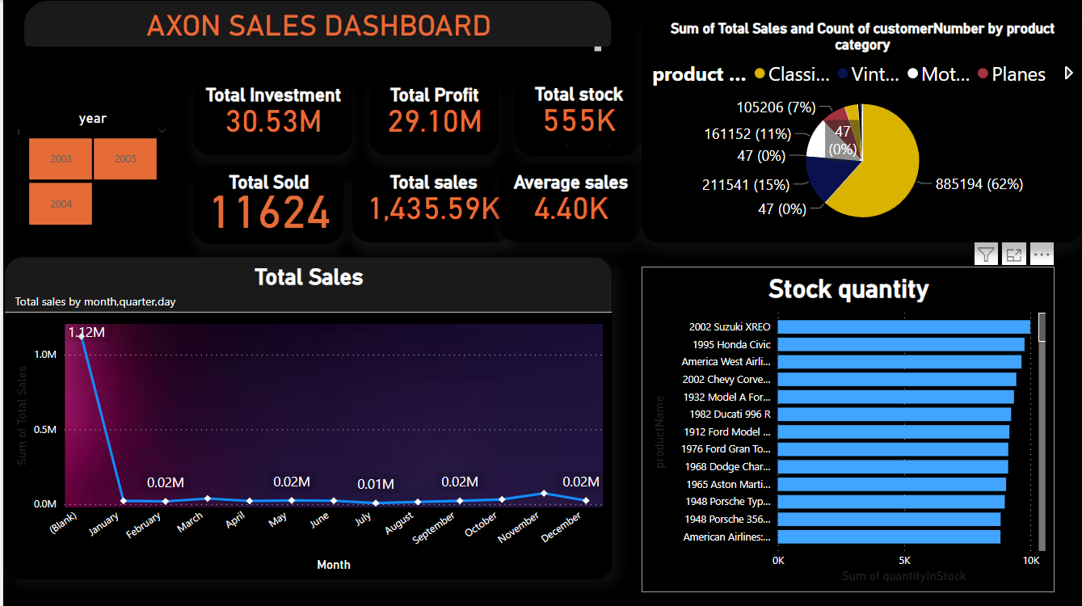

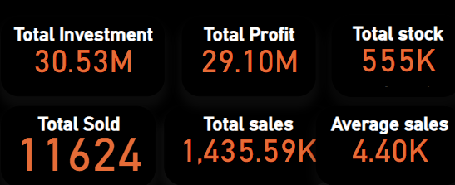

Total Investment: 3,05,34,316.23

Total Profit : 2,90,98,730.41

Total Sales :14,35,585.82

Total Stock : 555131

Total stock sold: 11624



The count of customer purchased the product mostly

* Classic cars :885194
* Vintage cars:211541
* Motor cycles:161152

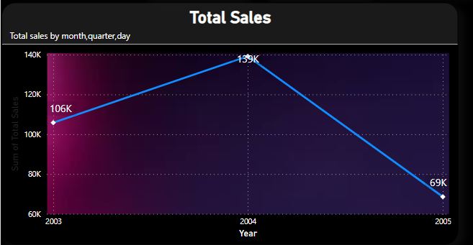

Sales are more in 2004 ,lot of sales decreased in 2005

Sales during 2003 quarterly,monthly,day wise analysis:

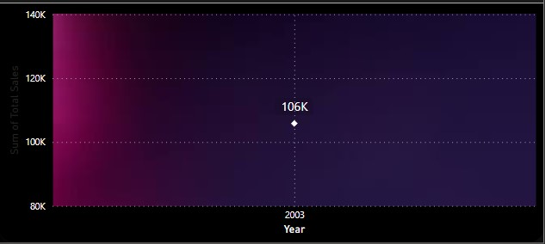

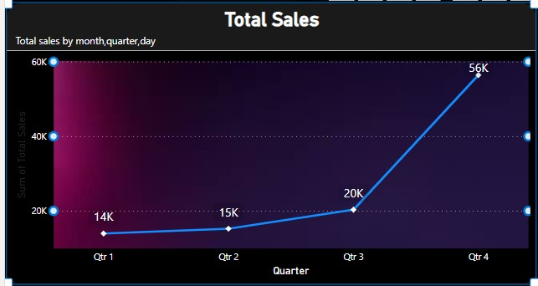

Between qtr 3 and qtr 4 sales are more in 2003 that means October ,November ,December months

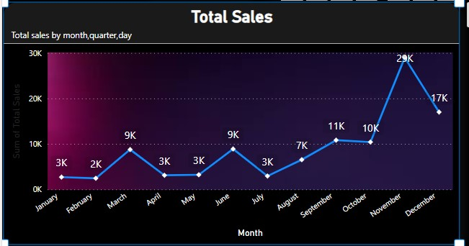

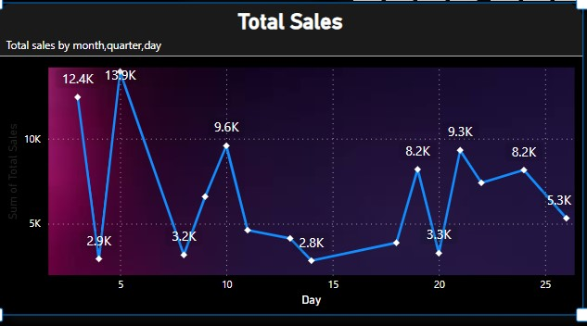

During 2004 the sales analysis

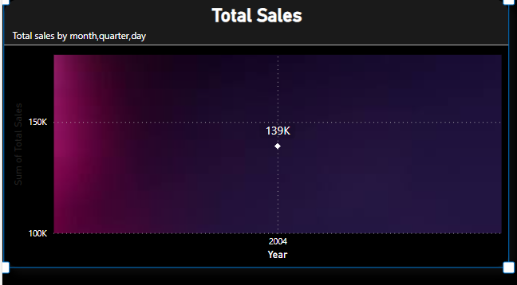

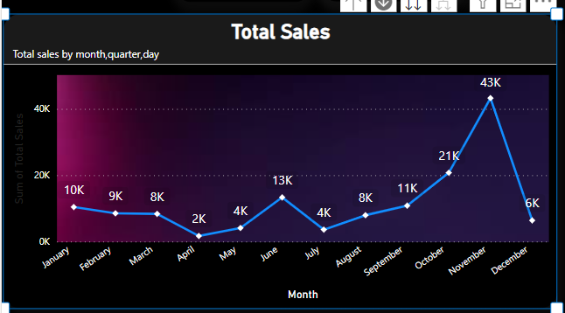

Sales are peak during october,november ,december and better in june

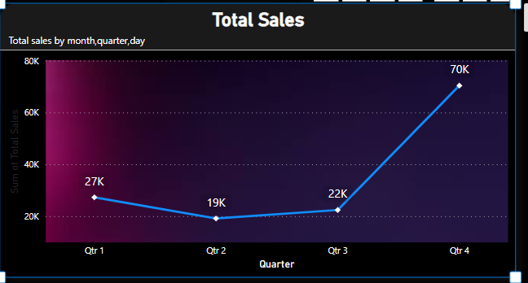

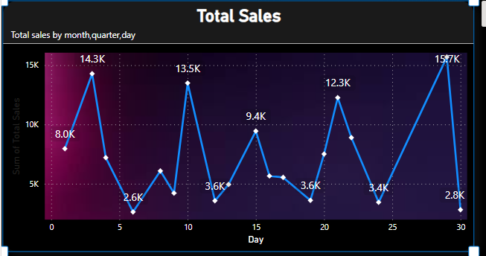

Sales analysis in 2005

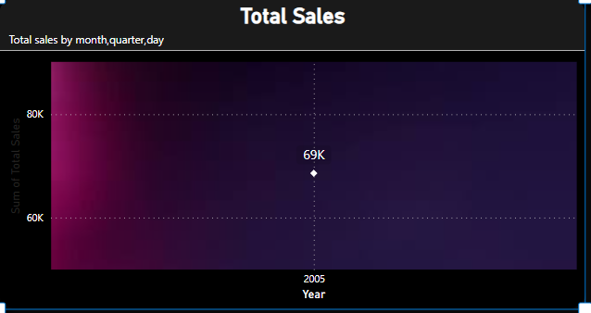

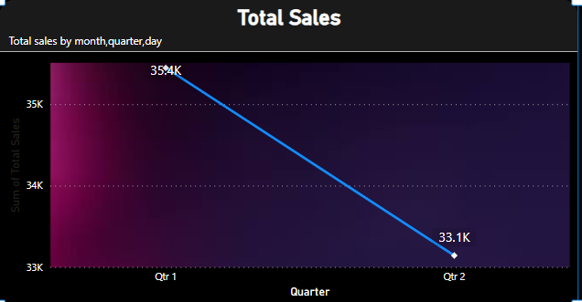

Most of the sales are occurred between january to may were in march most of the sales are occurred

After may there are no sales in 2005

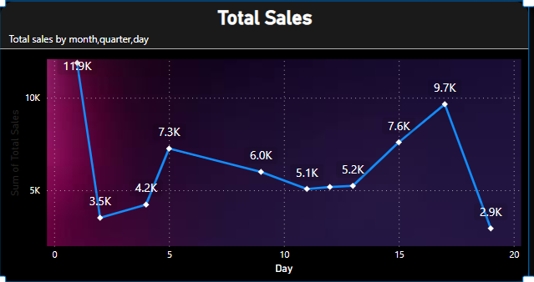

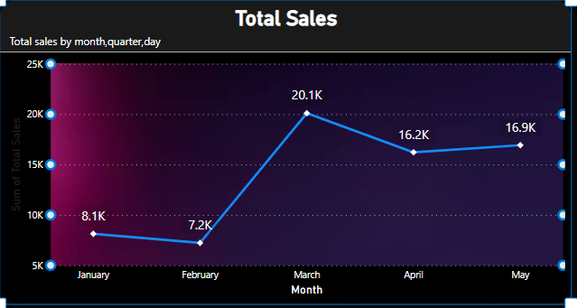

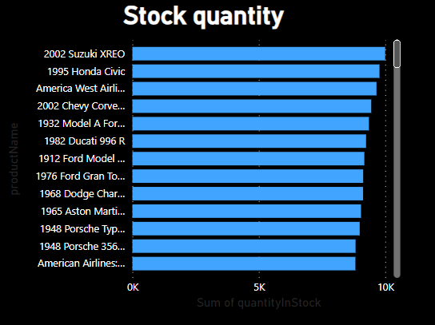

Quantity of stock by product name

Top 5 customer by total sales

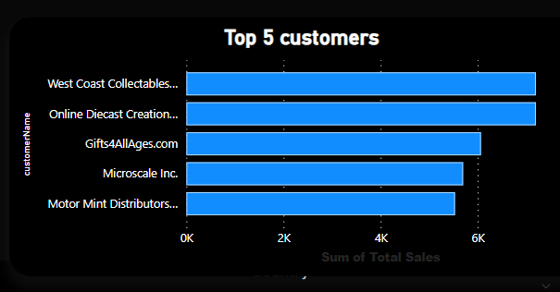

Top 5 products by sales

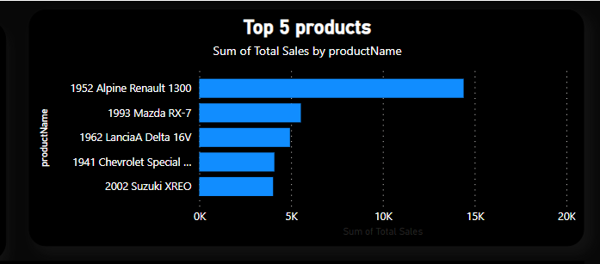

Sales through region

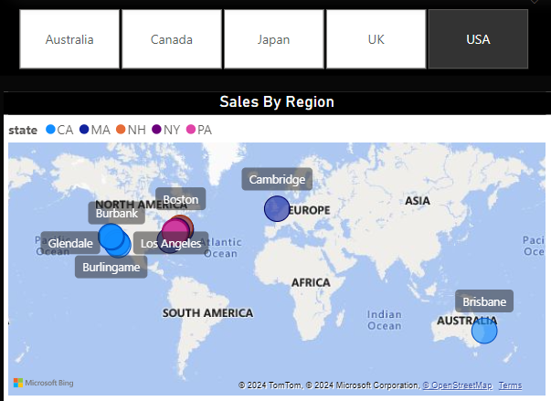

Most of the sales are occurred by USA in 2004

IN USA

states

CA

MA

NH

NY

PA

In that cities like

BRISBANE

CAMBRIDGE

BOSTON

NEWBED FORD

NASHUA

BRICKHAVEN

GLENDALE

BURLINGAME

BURBANK

In uk

State

Isle of wight

Cowes city

In Canada

State BC

Vancouver city

In Australia

2 states

NSW

VICTORIA

with 3 cities

MELBOURNE

CHATSWOOD

NORTHSYDNEY

PROFIT ANAYLYSIS

IN 2004 MONTHLY

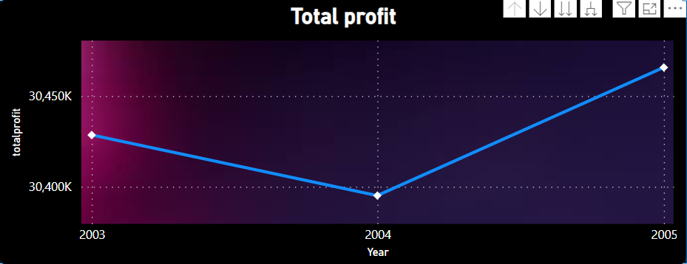

Profit in

2003 :3,042849954

Profit is more in April as well may lower in june

2004:3,03,9542.18

Profit is more in April then decreased a lot in November and then increased in December

2005:3,04,65,727.89

Profit in June to December is more because there are no sales in thet period

In this investment is more and the profit is not up to the mark and also loss is nearly 1,435,585.82